**Normalization**

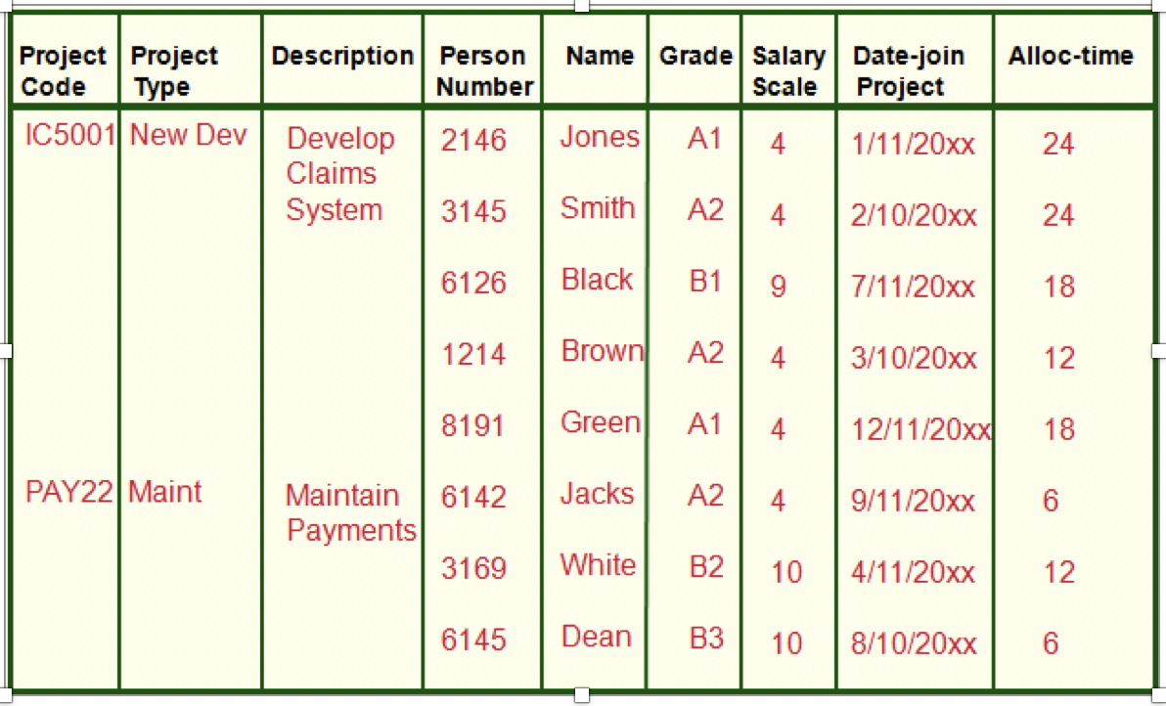

**Project**(Project_Code, Project_Type, Decription, Person_Number, Name, Grade, Salary_Scale, Date_Join_Project, Alloc_Time)

**UNF (selecting repeating group):**

**Project**(Project_Code, Project_Type, Description, {Person_Number, Name, Grade, Salary_Scale, Date_Join_Project, Alloc_Time})

**1NF**

**Project1**(Project_Code, Project_Type, Description)

**Project-Person1**(Project_Code, Person_Number, Name, Grade, Salary_Scale, Date_Join_Project, Alloc_Time)

**2NF**

* **Removing partial dependency**

Project_Code, Person_Number -> Grade, Salary_Scale, Date_Join_Project, Alloc_Time

Person_Number-> Name

Project_Code->

***Tables***

**Project2**(Project_Code, Project_Type, Description)

**Project-Person2**(Project_Code, Person_Number, Grade, Salary_Scale, Date_Join_Project, Alloc_Time)

**Person2**(Person_Number, Name)

**3NF**

* **Removing Transitive Dependency**

Since there is not transitive dependency. It is in 3NF.

***Tables***

**Project3**(Project_Code, Project_Type, Description)

**Project-Person3**(Project_Code, Person_Number, Grade, Salary_Scale, Date_Join_Project, Alloc_Time)

**Person3**(Person_Number, Name)